IoTree: A Way towards Smart Plantation

Surayya Obaid1, Hiba binte Tariq1, Tehreem Qamar 1,Aimun Tahir1 and Namrah Komal1

1 Jinnah University for Women, Karachi, Pakistan

**Abstract.** For decades, research is being done to find out the possible way of reversing or at least reducing climate change and global warming and out of all methods, the plantation is least arguable. It is found that planting trees in accordance with the needs of the environment actually helps in lowering the temperature, reducing carbon footprints, and certainly, it marks a positive impact on the well-being of individuals. Although plantation is not a process that brings noticeable changes instantly to the environment, but it is still considered as one of the elements whose scarcity has marked lethal impacts on the planet.

Considering the need of appropriate plantation, this paper proposes IoTree as a solution. It is a system composed of mobile and web app, that actually brings a platform to know the actual needs of an environment and enabling the people to do plantation in accordance with the needs recorded, via its prediction module. In addition to this, the user will also be able to monitor the parameters related to the growth of the plant which can further be consulted by the gardener via gardener’s consultation module. Also, through this system, people will contribute their part in the plantation campaign. Further, the paper mentions the benefits such system can have over the environment.

**Keywords:** Smart Plantation, Plant Prediction, Plant Monitoring, IoT, Algorithms.

1. Introduction

Our planet is warming, putting at risk not only our physical well-being, but the whole future [1]. With the evolution in technology and other industries, there comes the need to manage their impact on the environment. All the terms that we hear these days like global warming, depletion of earth's resources (like air, water, soil, etc.), destruction in the ecosystem, are the result of this revolution[2]. And it is noticeable that we can't keep ourselves away from the changes that are brought through technology but we can certainly lower down the worsening effect. During the course of the twenty-first century, scientific evidence points to global-average surface temperatures that are likely increasing by 2◦C-4.5◦C. The current rate of global warming is 2◦C per century. The global mean temperature will rise by at least 1.5◦C by 2050 [3]. This rise is temperature is what we call climate change.

Climate change has now become one of the most discussed issues in recent years. We can take the example of recent incidents like Amazon Rainforest fire[4], Australia bush fire [5], heavy floods in Kerala (India), Bangladesh, Nepal, Sri Lanka & cyclones in Southern Africa [6]. Another issue that world is witnessing, is the unanticipated number of climate refugees which has exceeded millions now. Since 2008, an average of 21.7 million people has been displaced each year by extreme weather-related disasters – the equivalent of 41 people every minute [7].

Karachi being home to 11% population of Pakistan has badly gone through impacts of climate change and now is most prominent contributor of CO2. If the temperature of Karachi continued increasing at the same rate, then it is possible that it will rise up to 3.9◦C till the end of this century [3]. Multiple studies suggest that plantation is one of most promising solution to this global warming and carbon emission issue. US Environmental Protection Agency found that the tree plantation can help in lowering down temperature up to 11-25 ◦C of outdoor environment and is same efficient and beneficial for indoor environment. Not only this, it is also calculated that a single mature tree is capable of removing 48 lbs. of carbon dioxide from atmosphere.

Considering the current scenario and future predictions about the climate change impacts, IoTree seems to be a potential solution to all these problems. The main objective of this system is to create awareness about the environmental needs and suitable plants in accordance with the needs of environment. This is being done by collecting the data of environmental constituents via network of sensors. This system also enables user to track their planted plants with the additional feature of gardener’s consultation.

The mentioned study is done in order to gain the knowledge about the similar systems working globally for the betterment of global warming as well as for mentioning our system along with its supporting material.

The main contributions of this study are:

* The proposal of a system which aims to purify air via natural means i.e. plantation.
* The benefits which can be achieved on implementation of the proposed system.

1. Literature Survey

We have studied several literary material provided by different researchers who have been studying the cause and effects of global warming the ways through which plantation can help in reducing the climate impact. This section is divided into 3 subsections. The first section discusses the restoration of climate via plantation; the second section gives the references of the developed systems on prediction of plants whereas the third section carries the developed monitoring systems.

* 1. Climate change via Plantation

There are two major ways of reverting climate change via plantation i.e. forestation and urban plantation[8]. Among these two, urban plantation seems the neglected one. Urban areas all around the world are more polluted than country side because of higher electricity consumption and industrial activities. In the interval of 4 years from 2008 to 2012, Particulate Matter concentration in urban area was 11.15 μg/m3 in contrast with 8.87μg/m3 in rural areas as calculated by US Environmental Protection Agency( EPA)[9].

Several efforts are made at international level to the fix or at least reduce this difference of quality of atmosphere in urban and rural areas. This includes massive urban plantation in metropolitans so that to lower down the impact of GHG emissions. However, in some cases this massive plantation without precise research brought adverse consequences. For instance, a plant called Conocarpus was planted extensively in Karachi, Pakistan. This plant has capability to grow rapidly due to which it is suggested to not to plant it in urban areas as it absorbs water from soil causing a number of issues. First of all, due to reduction of water concentration in ground, humidity in atmosphere gets reduced ultimately results in limiting rainfall. Due to this plantation, Karachi suffered from worst kind of heat strokes in the year 2015 and 2016 that went without rainfall. This makes it crucial to go through the characteristics of plants before planting it.

Another example is of Paper Mulberry trees that were planted back in 70`s when the capital was being developed. These trees release pollen grains twice a year which has caused increased number of Asthma patients in the city. Though these trees are planted in many other cities across the world and are perfect for their atmosphere[10].

A number of systems and concepts are proposed as solution to the problem of deforestation and lack of green habitats in urban areas but hardly any system is designed for the revival of the metropolitan’s environment. Concepts implemented for restoration and preservation of forest are actually applicable for urban areas too. Such as, Community Based Forest Management which is a powerful paradigm through which the community is welcomed to take part in forest restoration. CBFM was successfully implemented in the Philippine in 1995 where more than 80% of forest were cut off. The Government accepted public’s interference in order to restore the green land.

The same can be done to buck up the urban population for plantation campaigns. If the community takes part in fulfilling the environment need then it will give urban plantation a new face. Plantation campaigns run by public can help in the process of betterment of Air quality.

In another study[11], it is revealed that greenbelts of shrubs can impressively lower down carbon level. Indian Govt. has made it mandatory to do plantation over recommended area in and around industrial area. The study suggests that pollution tolerant shrubs can prove a boon and an environment friendly solution in reducing Air pollution level. It says 65-600 ft. wide buffer can reduce Air pollutants level up to 40-45 percent.

* 1. Varied Natured of Plants

Plants don’t only vary in their appearance but there are also significant differences in the impacts they mark on environment. Even impacts of same plants in different regions, climate conditions and environment are sometimes contrary as discussed in above examples.

Some of indoor plants that are categorized as ornamental plants are considered as dangerous for the habitants because of their impression on the surroundings. A plant called Poinsettia causes irritation in skin when exposed to its sap (<https://www.thespruce.com/dangerous-indoor-plants-children-and-pets-4067447>). Another plant Ficus causes reaction and allergies on skin for people with sensitive skin. From these example, we can deduce that some of the plants aren’t suitable for all in every environment.

* 1. Prediction/ Suggestion Systems

Environmental and meteorological data makes a really huge impact on the selection of plants for a particular region. A precise selection of plants can make the environment a lot better than random selection[12]. Recommender systems for plants usually carry out the recommendation process on the basis of people's choice. Some of the recommender systems are there for appropriate crops i.e. crops that are more beneficial in accordance with the season and environmental and meteorological data.

A research work was done in Thailand in order to make a recommender system for plant varieties selection with the help of collected data [13]. They used WEKA( Waikato Environment for Knowledge Analysis, developed at University of Waikato, New Zealand, used for Data Mining) and Google Maps API in making their software. They have exploited environmental data such as average temperature, average air pressure, soil texture, type of area, pH value, etc. for obtaining results via decision trees and above mentioned resources.

Another study was carried out in Davis, California [14] in which they have studied how they can gain benefits from maintaining tree inventory in the city. They took a sample of 2393 public and 696 private trees. They modeled the data in a way that it produces three major pieces of information including species composition, age distribution, and condition, etc. Remaining data includes magnitude of environmental and aesthetic benefit, resource value, resource management needs like sustainability factors, pruning and young tree care, conflict mitigation, etc. The study shows that there was 16% improved Air Quality (due to reduction in CO2 concentration) because of the trees planted there.

Another system, Soil Based Fertilizer Recommendation System [15] is defined as a smart fertilizer recommender which provides the basic agricultural information about fertilizers and soil. The system allows sensors to assimilate the nutrients of soil and after completing analysis over the collected information, the data is then stored in the database. The system then recommends the suitable fertilizer based on nutrient status stored in the database. The system uses Naïve Bayes algorithm for classification of nutrients and the fertilizer recommendation has been done through mobile application or website. This is a Client-Server Architecture, where the Client and Server are connected through the cloud.

* 1. Monitoring Systems

In order to sustain the environmental condition and to observe the pleasant atmosphere within the urban areas, it is therefore significantly required to monitor the condition of street trees. In regard to this, the smart irrigation system [16] interfaced with NodeMCU ESP8277 controller was developed to monitor the soil condition of the street trees. In addition to this, the smart system also provides the automatic watering services. This watering service is provided by the connection of pipes and valves and it is controlled by overseeing the opening and closing of valves.

In this smart system, three sensors are implemented, soil moisture sensor, humidity and temperature sensor and rain sensor. These sensors are connected to the Nodemcu ESP8266 microcontroller.

Since the system also provides the feature of wireless communication therefore it works with the connection to the internet. For authentication, the system takes username and password which is further processed to set up MQTT broker, being used to transmit data to continue GUI of the system.

Along with this, another system named plant health monitoring system [17] was also seen which aimed to monitor the plant’s condition. This system was implemented when similar research was observed in tomato greenhouse in the South of Italy[18] and in Western Finland [19] . In their proposed system they used Sensinode’s sensor platform to measure four environmental key variables. The sensors used were SHT75 humidity/temperature sensor and TSL262R light irradiance sensor, and Figaro’s TGS4161 CO2 sensor. These sensors collect the climate variables and transmit the data to the gateway node since they have used star topology.

The key feature of this system is to transmit the data through wireless communication using cloud platform. Therefore, in regard to this feature, ubidots IoT cloud platform was used which is like a PaaS (Platform as a service) that provide some services useful in IoT ecosystem.

Smart Plant Monitoring System [20] shows how the integration of ambient intelligent systems with plant monitoring makes plantation easier and effective. With the consolidation of ambient intelligence based device .Net Gadgeteer and plant monitoring, people can easily monitor their plants as it handles the plant monitoring system. The implementation includes a cloud-based server, hardware devices, and a mobile device. This system relies on two types of modes, one is “Direct Mode” in which the processing is based upon the data collected by the sensors and the second is “Advanced Mode” in which cloud server relies on the Weather Forecast Information along with input values predicted by the sensors. Through mobile device (Android/IOS) user can control and be able to see the current status of plants.

Along with these systems, Tomen (Tomato Garden) [21] is also a system that provides two benefits at a time, helps in monitoring of plants and provides smart gardening services using IoT with the help of Raspberry Pi controller. The main parameters for the productive growth of plants (soil, air, temperature, humidity, sunlight, soil moisture and pH) directly monitored by the help of sensors. The user can easily monitor the garden with the help of a camera provided in this system. The purpose of smart gardening is to provide ease and lesser the user’s physical efforts. The user can install smart gardening application by using any android supporting device which will generate the alerts for maintenance. In this system, a solenoid Water Valve automatically controls the water system and through this feature, the system saves water, utility and electricity bills.

Thus, the features included in the mentioned system are observed to possess the similar working properties with our proposed system and as they were integrated and tested successfully, therefore they provide a light direction to the implementations for our proposed system.

1. IoTree – The Proposed System

IoTree is a smart solution for bridging the gap of understanding that a typical plant owner or gardener has regarding plantation i.e. what needs to be planted in an area and when. This solution works by recommending the right plant which is the best choice for the betterment of the environment of that particular locale. This can be implemented with the development of a unit which captures the environmental condition in terms of certain parameters; therefore a hardware unit is made to carry out this task as depicted in fig.1. Right after the plantation of plants, the system also generates alerts for maintenance. This will be carried out by means of number of sensors deployed there to assess real time values. Data collected from these sensors will be combined in order to make decision for right choice of plant. Similar approach will be taken to monitor the plant i.e. on the basis of gathered data, timely notifications will be generated to let the user know what plants need at that moment.

The system also ensures that the plants suggested are in the approach of users by providing the e-commerce of seeds.

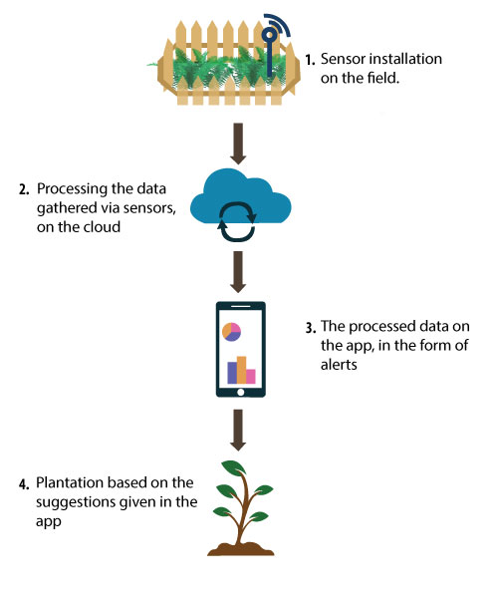Alongside these features, through the app portal the user is also able to contact the nearest located gardener to avail the gardening services on one touch.

**Fig. 1. Data flow throughout the system**

As masses are gaining awareness about the need for plantation, there comes the need for a force that helps in channelizing campaigns for plantation. IoTree also assist users who are intended to donate for the areas that need plantation critically by helping them in initiating plantation campaigns.

1. Methodology

The methodology which is applied to this system is split into 3 major parts that are; formation of a network of sensors, the recommendation of plants (that includes e-commerce of seeds, alerts generation for maintenance of plants, consultation with gardeners) and campaign for plantation. The step taken first is based on the vital segment of the system i.e. to form a network of sensors to read the elements from the atmosphere and respective soil for a defined interval of time. These elements include temperature, humidity, degree of sunlight, and other air constituents like the concentration of nitrogen, carbon, etc. For soil, pH level, moisture, salinity level, and the water level will be noticed. All these readings, captured via sensors are obtained by a middle layer; component, responsible for communication among units of the system. Based on such readings, the system with the help of algorithms suggests a suitable plant with all the ratios of mentioned elements needed by it.

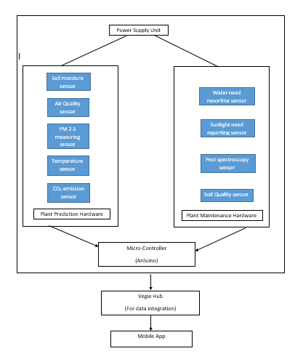

The system then had the development of another module which provides convenience by providing the E-Commerce of seeds of the suggested plants. After plantation, the system gets enabled to generate the alerts based on the real-time needs of the planted plants. The tracking of the plants is also done via hardware unit. Hence the alerts focus the needs of a plant such as water level maintenance, protection from pests, fertilizers (as the soil itself isn’t sufficient as a source of nutrients), appropriate sunlight, etc. These alerts include the presence of elements and the ratio of constituents captured by it along with this the notification of the instructions e.g. Water your plant.

 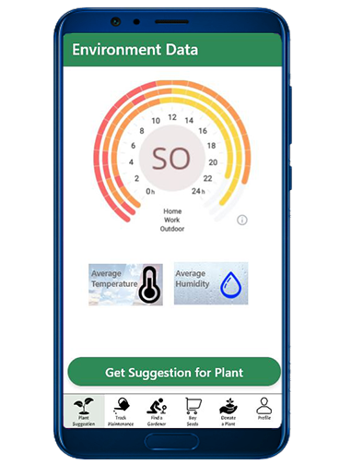 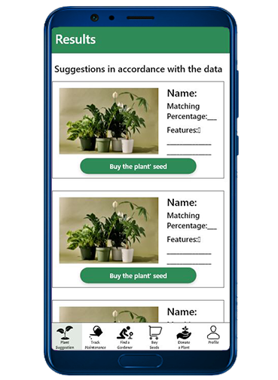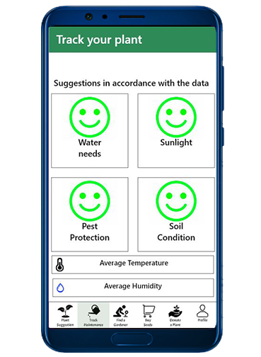

The system is designed in a way so that it also provides consultation from the gardeners. For this part, the system take the request according to the location and responds as a provision of the list of gardeners available for the respective location.

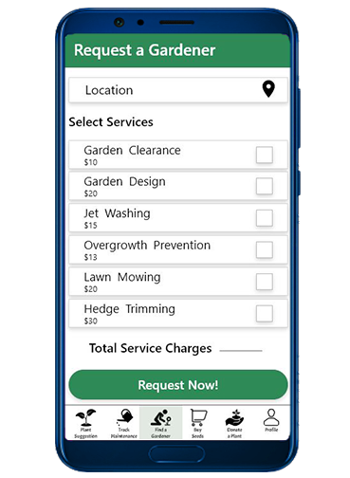 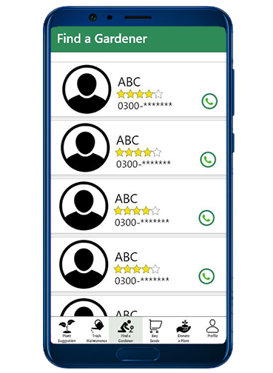

IoTree is designed and developed in a way that it also acts as a platform to help out the people willing to be a part of donation for the plantation campaign. The system keeps the records of the donors so that it bridges up the gap between donors and the deprived or impoverished areas.

The plantation mechanism and the considerations for indoor and outdoor environment have a different direction because the attributes for plant’s suggestions are not applied in the same manner for both. The next section states how the IoTree system can be implemented in indoor and outdoor environment.

**IoTree for Indoor Plantation:**

Since the indoor environment is closer to the people living in there, therefore it has an immense effect on them. If the atmosphere is pleasant, it is indeed favorable to the health of people, but in other scenarios, some of the events expose few adverse elements in the atmosphere which directly or sometimes indirectly affect the health of living beings.

For instance, the active smokers inside the home can even affect the nearby non-smokers, which is unfavorable to the health at the same level as of the active smoking. As mentioned in the section 2, the “Snake Plant” can reduce the hazardous effects of smoke from the indoor environment by filtering the toxic elements.

Along with the Snake Plant, the section also mentioned that the massive amount of plantation of the flowering house plants like Peace Lilies, Sago Palm, Caladium, etc. which have variability in their nature, can cause vomiting, diarrhea, and even liver failure. Other than that, these flowering plants are not only unfavorable to the humans, but also perilous to the pets too.

Considering these facts, the IoTree system is made in such a way that it benefits the indoor environment. This system will first have the hardware unit installation in the indoor environment. Afterwards, the hardware system will detect all the values of the described parameters which would follow the same flow, as mentioned in section 4, i.e. the values would be stored in cloud environment for processing, which would indicate the most suitable plant in accordance with the indoor environment.

The plant suggestions would vary from indoor environment to indoor environment following the main objective of the system i.e. Plantation according to its quality appropriateness.

In short, the implementation of IoTree for indoor plantation purposes is serving its high duty for making the indoor environment pleasant.

**IoTree for Outdoor Plantation:**

Since the outdoor environment has an evident impact on the lives of people therefore government also focuses on making an area beautiful by planting the beautiful trees alongside the streets and in the parks but they don’t focus what impacts those plants are leaving behind.

For Example, as mentioned in the section 2.1, government took an initiative to plant the conocarpus trees, which were extensively planted in Karachi. As those trees were planted without any prestudy therefore they left an uncertain impact in the sense of reduction in the water concentration in the ground and limiting the rainfall. These impacts ultimately caused heatstroke in the year 2015 and 2016.

Along with conocarpus trees, this section also mentioned the paper mulberry trees which were also extensively planted in Islamabad without any research of suitability. Due to its twice a year pollen release, it started causing asthma among the people of Islamabad.

Therefore it was noticed that the government is undoubtedly putting an effort in plantation but the IoTree system will make it possible for the government to plant the most suitable plants which would prevent the plants to leave perilous effects and will make plantation able to benefit the environment. This process will be carried via IoTree app, which would suggest the plants not only on the basis of temperature, air humidity level and air constituents but also on the basis of soil texture, soil humidity level.

Conclusively, IoTree which is developed considering both the indoor and outdoor environment, is successfully benefitting the both environments.

1. Benefits of the System
   1. Elimination of Risks associated with Plant Choice

Plantation based on choice and plantation-based on needs have different outcomes. The choice may not suit the environment but if it's done in accordance with the characteristics and needs of surrounding, then it will benefit the surrounding. IoTree aims to eliminate such risks that may occur due to inappropriate plantation.

* 1. Ceasing the Way of Consequences of Human error in Maintenance

Whether because of the busy schedule or lack of care, a plant often dies because of human negligence. If the process becomes independent from a human intervention then mortality rates of plants can be reduced up to a significant level. The maintenance module will generate timely alerts as well as alerts based on plant' necessities.

* 1. Green Computing

The term Green Computing refers to the aim of IT giants to leave the least possible ill effects on the environment as computing causes invisible and inevitable damages to our habitat [22], there are two possible ways to achieve this goal. One way is to use resources in an eco-friendly way while the other focuses on ensuring that the resources are more than enough. By planting maximum, green computing can be practiced easily which is one of our motives.

* 1. Air Quality Treatment & Betterment

NASA has experimented in the late '90s in which they isolated small area and planted with the aim to purify the Air, which went successful [23] The same methodology can be applied on larger scales with some controlled parameters in order to get better Air quality. Especially in areas like Saddar (Karachi, Pakistan), this kind of treatment is pivotal for the future because the area is densely populated with least environmental accommodations.

* 1. Filling up the Communication gap between User and Gardener

As discussed earlier, people in our region don't usually believe in what is digitally recommended. They always try to authenticate it from their trusted source which in this case, is the gardener. That's why, for their satisfaction, the system will provide the consultation services of a gardener at their doorsteps.

* 1. Plant donation campaigns

European organizations like Trees4peace [24] Trillion Trees Campaign [25] Outdoor Conservation [9] etc. have taken a great initiative in order to make Earth green again. This system aims to do the same in Pakistan, where very few authorities, public figures, and even the public seems to have an interest in reducing pollution. With the help of this system, these masses that have common interest of join hands to bring the plantation campaigns through donations in the areas that scarce.

1. Conclusion

There is lack of focus on the matter of effectiveness of plants in reversing climate change though a lot of improvement in the environment can be achieved just by planting what’s needed. Although there are several researches done on finding out the attributes and effectiveness of plants but there is void when it comes to implementing these findings with the help of technology. The system proposed is capable of helping in retaining the environmental beauty and atmospheric purity through natural means. This solution is chosen to be implemented smartly because in the world of digital living, the people would like to tackle the plantation via automation. The hardware and the software module is developed separately with their respective requirements while the successful integration of the modules enabled IoTree to work.

The IoTree was also planned considering its extension towards AI and AR. Automatic watering services will be provided using the algorithms of ML, when the system alerts the decrement in the water level of the plant. Along with this, the system will additionally have the fancy feature using AR which will enable the user to visualize the look of their place before and after plantation with the growth length of plant.

References

[1] Umair Shahzad, “Global Warming: Causes, Effects and Solutions,” no. May, 2017, doi: https://www.academia.edu/15180958/Global_Warming_Causes_Effects_and_Solutions.

[2] N. A. Aquilas, N. G. Forgha, M. Mobit, and M. S. Agbor, “Natural Resources Depletion and Economic Growth:,” *Natural Resource Endowment and the Fallacy of Development in Cameroon*, no. April 2020, pp. 31–56, 2020, doi: 10.2307/j.ctvvh85v5.8.

[3] S. H. Sajjad, B. Hussain, M. Ahmed Khan, A. Raza, B. Zaman, and I. Ahmed, “On rising temperature trends of Karachi in Pakistan,” *Climatic Change*, vol. 96, no. 4, pp. 539–547, 2009, doi: 10.1007/s10584-009-9598-y.

[4] P. Fearnside, “Fire in the Tropical Biota,” vol. 84, no. December, 1990, doi: 10.1007/978-3-642-75395-4.

[5] “Catastrophic Australian bushfires derail research.” https://www.nature.com/articles/d41586-020-00130-4 (accessed Jul. 25, 2020).

[6] “5 natural disasters that beg for climate action | Oxfam International.” https://www.oxfam.org/en/5-natural-disasters-beg-climate-action (accessed Jul. 25, 2020).

[7] “Climate change ‘will create world’s biggest refugee crisis’, experts warn.” https://helprefugees.org/news/climate-change-refugee-crisis/?Gclid=cjwkcaia-vlybrbweiwazo-kgvmdftop2pfyx3q8ctwsrdgjgzxzv_xpdhf2orswhgeqfmbpq7lwbshoccnuqavd_bwe (accessed Jul. 25, 2020).

[8] D. D. Jayagoda, “A unique case study of tree plantation bringing increased forest cover to Puerto Princesa, Philippines,” *Journal of Sustainable Development*, vol. 8, no. 1, pp. 138–155, 2015, doi: 10.5539/jsd.v8n1p138.

[9] “European Outdoor Conservation Association | EOCA | Conservation Funding | Conservation Grants.” https://www.outdoorconservation.eu/ (accessed Jul. 25, 2020).

[10] J. Iqbal and J. A. Khan, “m er ci al,” no. November, 2019, doi: 10.4081/gh.2019.727.

[11] M. Koul, “PLANTATION OF SHRUBS IN URBAN AREAS TO CONTEST,” no. March 2016, 2019.

[12] S. M. Pawson *et al.*, “Plantation forests, climate change and biodiversity,” *Biodiversity and Conservation*, vol. 22, no. 5, pp. 1203–1227, 2013, doi: 10.1007/s10531-013-0458-8.

[13] S. E. Maco and E. G. McPherson, “A practical approach to assessing structure, function, and value of street tree populations in small communities,” *Journal of Arboriculture*, vol. 29, no. 2, pp. 84–97, 2003.

[14] J. Prohens, “Plant breeding: A success story to be continued thanks to the advances in genomics,” *Frontiers in Plant Science*, vol. 2, no. SEP, pp. 1–3, 2011, doi: 10.3389/fpls.2011.00051.

[15] K. Bodake, R. Ghate, H. Doshi, P. Jadhav, and B. Tarle, “Soil based Fertilizer Recommendation System using Internet of Things,” *Journal of Engineering Sciences*, vol. 1, no. June, 2018, doi: 10.18311/mvpjes/2018/v1i1/18273.

[16] W. Al-Gumaei, S. K. Selvaperumal, R. Abdulla, and C. Nataraj, “Smart Tree Care System with Internet of Things,” *Research Journal of Applied Sciences, Engineering and Technology*, vol. 15, no. 9, pp. 328–336, 2018, doi: 10.19026/rjaset.15.5923.

[17] S. Siddagangaiah, “A Novel Approach to IoT Based Plant Health Monitoring System,” *International Research Journal of Engineering and Technology (IRJET)*, vol. 3, no. 11, pp. 880–886, 2016, [Online]. Available: https://www.irjet.net/archives/V3/i11/IRJET-V3I11154.pdf.

[18] A. Lambebo and S. Haghani, “A Wireless Sensor Network for Environmental Monitoring of Greenhouse Gases,” *ASEE 2014 ZONE 1 Conference*, p. 4, 2014.

[19] V. R. Deore and P. V. M. Umale, “Wireless Monitoring of the Green House System Using Embedded Controllers,” *Ijser*, vol. 3, no. 2, pp. 1–8, 2012.

[20] S. Sadasivam, V. Vadhri, and S. Ramesh, “Smart Plant Monitoring System,” no. March 2016, 2015, doi: 10.13140/RG.2.1.2915.6563/1.

[21] R. Elangovan, D. N. Santhanakrishnan, R. Rozario, and A. Banu, “Tomen:A Plant monitoring and smart gardening system using IoT,” *International Journal of Pure and Applied Mathematics*, vol. Volume 119, no. March, pp. 703–710, 2018, [Online]. Available: https://www.researchgate.net/publication/323811801_TomenA_Plant_monitoring_and_smart_gardening_system_using_IoT.

[22] C. R. Chowdhury, A. Chatterjee, A. Sardar, S. Agarwal, and A. Nath, “A Comprehensive study on Cloud Green Computing : To Reduce Carbon Footprints Using Clouds A Comprehensive study on Cloud Green Computing : To Reduce Carbon Footprints Using Clouds,” no. May 2015, 2013.

[23] L. S. Sheldon and J. Keever, “NASA Contractor Report 3947 Collection and Analysis of NASA Clean Room Air Samples FOR REFERENCE.” Accessed: Jul. 25, 2020. [Online]. Available: https://ntrs.nasa.gov/search.jsp?R=19860005888.

[24] “Trees for Peace - AYUDH Europe.” https://trees4peace.eu/ (accessed Jul. 25, 2020).

[25] “Welcome | Trillion Tree Campaign.” https://www.trilliontreecampaign.org/ (accessed Jul. 25, 2020).